- November 16th:
- Experimented with different kinds of grippers to see what works best
- Found a combination of ‘fingers’ and rubber pads to keep enough friction with the lid, to open it, and also to hold the bottle on the table
- The end-effectors should be the flat, square rubber ones (do not use rounded ones as friction is not enough)
- To hold the bottle in place on the table, a combination of one small gripper and one wide one works best
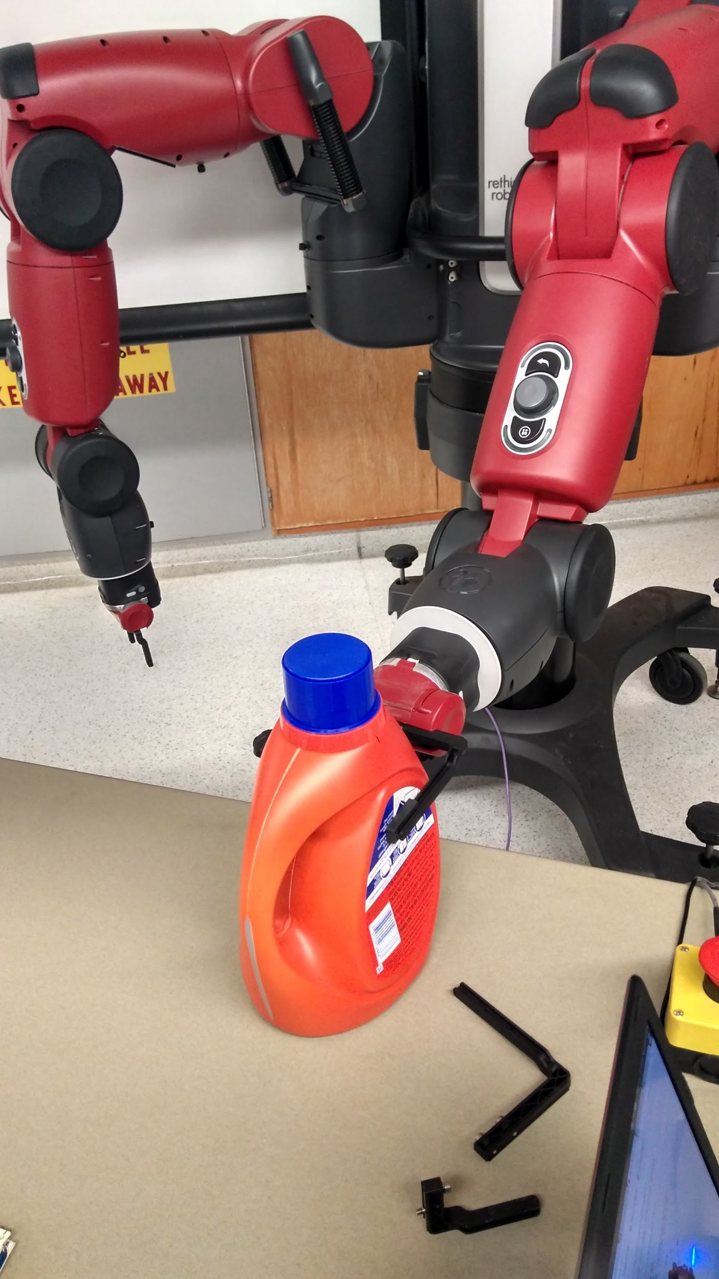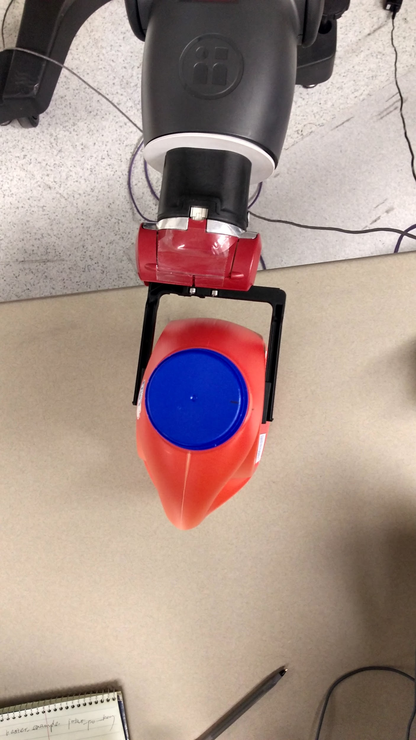

2. November 21st:
- We (Wanning and Ahalya) were working on the Inverse Kinematics Service for Baxter
- Wanning connected her laptop to Baxter, and we used this command to find out the Cartesian coordinates, velocity and effort for any given arm configuration of Baxter: rostopic echo /robot/limb/<side>/endpoint_state
- Used code from ‘IK-Service Code Walkthrough’ (http://sdk.rethinkrobotics.com/wiki/IK_Service_-_Code_Walkthrough) to get the joint angles for Baxter, given a particular set of Cartesian coordinates. This was successful.

